***ANUDIP FOUNDATION***

A Project Report on

**MEDICAL DIAGNOSTIC SYSTEM**

By

Batch: ANP-C7344

Student ID: AF0368261

Name: Shraddha Darekar

**Under the Guidance of**

Mrs. Rajshri Chandrabhan Thete

MEDICAL DIGNOSTIC SYSTEM

**Entities:**

* Patient
* Medical Report
* Doctor
* Tests
* Charges

**VARIOUS ENTITIES:**

1. **Patient**

* Pat_id(Primary Key)
* PName
* PDiagnosis
* pAddress

1. **Medical Report**

* Rep_id
* Rep_type
* Rep_desc
* Pat_id(FK)
* Tst_id(FK)

1. **Doctor**

* Doc_id
* Doc_name
* Doc_mobile
* Doc_email
* Doc_adds
* Doc_pass

1. **Tests**

* Tst_id
* Tst_Desc
* Tst_type
* Tst_name
* Pat_id(FK)

1. **Charges**

* Chr_id
* Chr_type
* Chr_total amount
* Pat_id(FK)

**ENTITY RELATIONSHIP DIAGRAM – MEDICAL DIAGNOSTIC SYSTEM**

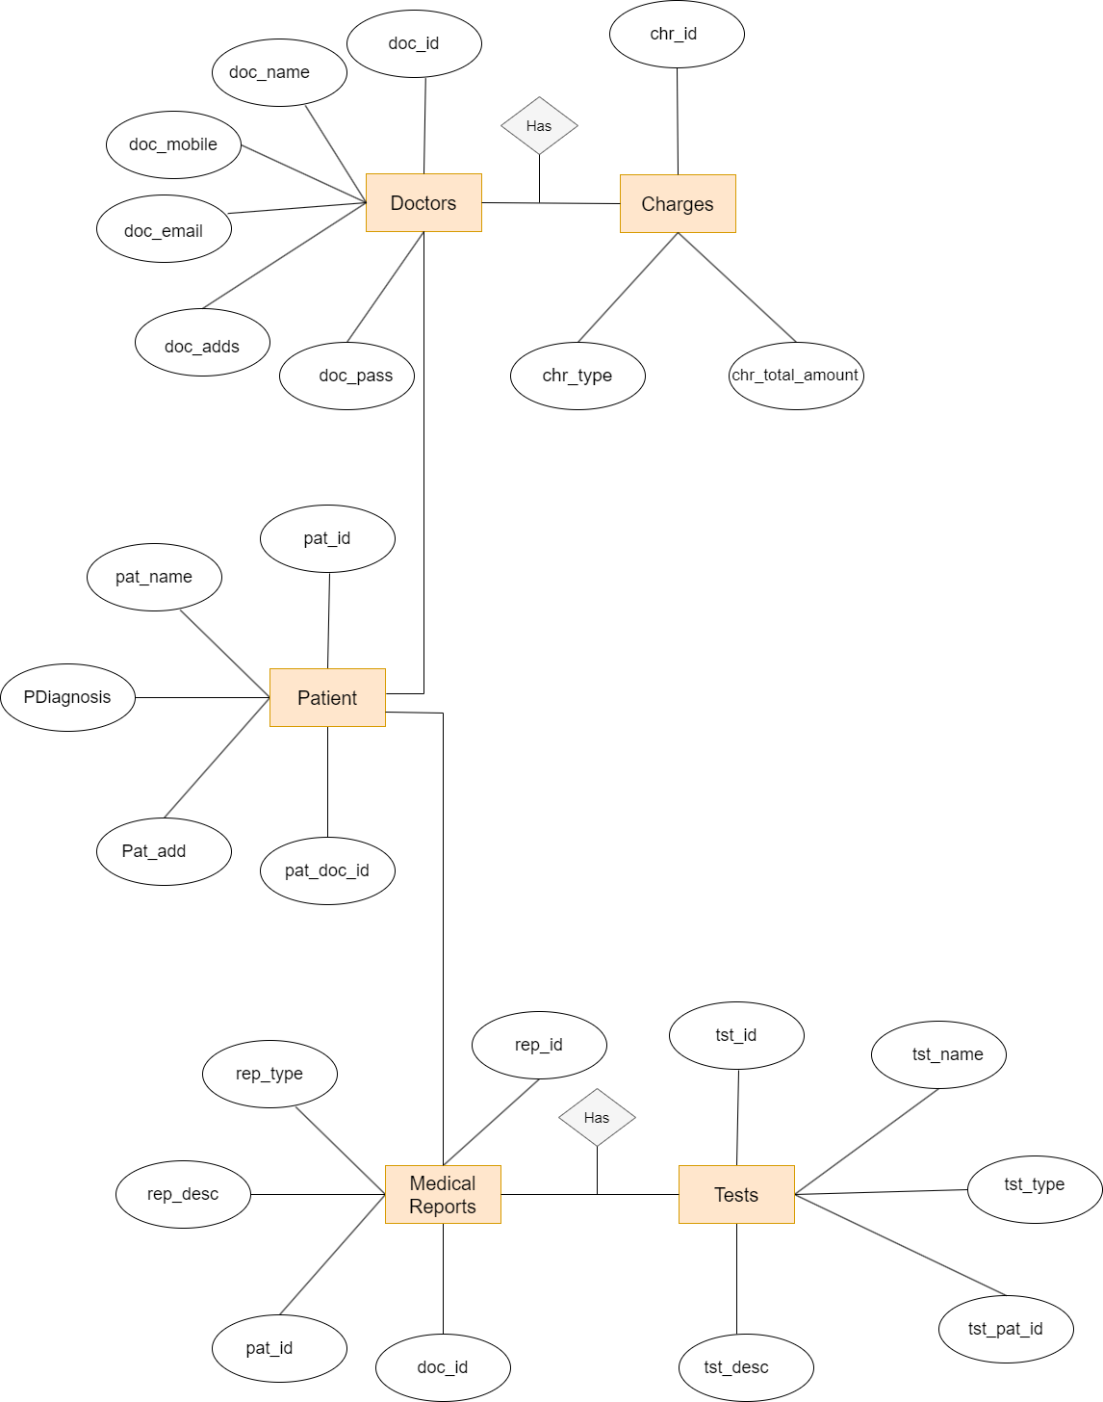

**DATABASE CREATION:**

mysql> DROP DATABASE medical_dignostic_system;

Query OK, 4 rows affected (0.07 sec)

mysql> USE medical_dignostic_system;

Database changed

mysql> CREATE TABLE Patient (

-> Pat_id INT PRIMARY KEY ,

-> PName VARCHAR(100),

-> PDiagnosis VARCHAR(255),

-> pAddress VARCHAR(255)

-> );

Query OK, 0 rows affected (0.04 sec)

mysql> insert into Patient(Pat_id,PName,PDiagnosis,pAddress) values(1,'Shirisha','Lung Cancer','Pune');

Query OK, 1 row affected (0.02 sec)

mysql> insert into Patient(Pat_id,PName,PDiagnosis,pAddress) values(2,'Rohit','Skin infection','Pune');

Query OK, 1 row affected (0.02 sec)

mysql> insert into Patient(Pat_id,PName,PDiagnosis,pAddress) values(3,'Prerna','Fever','Latur');

Query OK, 1 row affected (0.01 sec)

mysql> insert into Patient(Pat_id,PName,PDiagnosis,pAddress) values(4,'Harsh','Fever','Solapur');

Query OK, 1 row affected (0.01 sec)

mysql> insert into Patient(Pat_id,PName,PDiagnosis,pAddress) values(5,'Lata','Food Poisoning','Akkalkot');

Query OK, 1 row affected (0.01 sec)

mysql> select * from Patient;

+--------+----------+----------------+----------+

| Pat_id | PName | PDiagnosis | pAddress |

+--------+----------+----------------+----------+

| 1 | Shirisha | Lung Cancer | Pune |

| 2 | Rohit | Skin infection | Pune |

| 3 | Prerna | Fever | Latur |

| 4 | Harsh | Fever | Solapur |

| 5 | Lata | Food Poisoning | Akkalkot |

+--------+----------+----------------+----------+

5 rows in set (0.00 sec)

mysql> CREATE TABLE Medical_Report (

-> Rep_id INT PRIMARY KEY,

-> Rep_type VARCHAR(50),

-> Rep_desc TEXT,

-> Pat_id INT,

-> Tst_id INT,

-> FOREIGN KEY (Pat_id) REFERENCES Patient(Pat_id),

-> FOREIGN KEY (Tst_id) REFERENCES Tests(Tst_id)

-> );

Query OK, 0 rows affected (0.10 sec)

mysql> DESC Medical_Report;

+----------+-------------+------+-----+---------+-------+

| Field | Type | Null | Key | Default | Extra |

+----------+-------------+------+-----+---------+-------+

| Rep_id | int | NO | PRI | NULL | |

| Rep_type | varchar(50) | YES | | NULL | |

| Rep_desc | text | YES | | NULL | |

| Pat_id | int | YES | MUL | NULL | |

| Tst_id | int | YES | MUL | NULL | |

+----------+-------------+------+-----+---------+-------+

5 rows in set (0.02 sec)

mysql> CREATE TABLE Doctor (

-> Doc_id INT PRIMARY KEY,

-> Doc_name VARCHAR(100),

-> Doc_mobile VARCHAR(15),

-> Doc_email VARCHAR(100),

-> Doc_adds VARCHAR(255),

-> Doc_pass VARCHAR(255)

-> );

Query OK, 0 rows affected (0.04 sec)

mysql> insert into Doctor(Doc_id,Doc_name,Doc_mobile,Doc_email,Doc_adds,Doc_pass) values(101,'Ravi Sharma','9359423529','ravisharma@gmail.com','Akkalkot','1234');

Query OK, 1 row affected (0.01 sec)

mysql> insert into Doctor(Doc_id,Doc_name,Doc_mobile,Doc_email,Doc_adds,Doc_pass) values(102,'Riya Mathur','9374895739','riyamathur@gmail.com','Nagpur','0000');

Query OK, 1 row affected (0.01 sec)

mysql> insert into Doctor(Doc_id,Doc_name,Doc_mobile,Doc_email,Doc_adds,Doc_pass) values(103,'Priti Hulle','8087530280','pritihulle@gmail.com','Nagpur','0110');

Query OK, 1 row affected (0.01 sec)

mysql> insert into Doctor(Doc_id,Doc_name,Doc_mobile,Doc_email,Doc_adds,Doc_pass) values(104,'Varun Jadhav','7385935205','varunjadhav@gmail.com','Pune','@123');

Query OK, 1 row affected (0.02 sec)

mysql> insert into Doctor(Doc_id,Doc_name,Doc_mobile,Doc_email,Doc_adds,Doc_pass) values(105,'Tanmay Chavan','7387530280','tanmaychavan@gmail.com','Mumbai','1@23');

Query OK, 1 row affected (0.01 sec)

mysql> select * from Doctor;

+--------+---------------+------------+------------------------+----------+----------+

| Doc_id | Doc_name | Doc_mobile | Doc_email | Doc_adds | Doc_pass |

+--------+---------------+------------+------------------------+----------+----------+

| 101 | Ravi Sharma | 9359423529 | ravisharma@gmail.com | Akkalkot | 1234 |

| 102 | Riya Mathur | 9374895739 | riyamathur@gmail.com | Nagpur | 0000 |

| 103 | Priti Hulle | 8087530280 | pritihulle@gmail.com | Nagpur | 0110 |

| 104 | Varun Jadhav | 7385935205 | varunjadhav@gmail.com | Pune | @123 |

| 105 | Tanmay Chavan | 7387530280 | tanmaychavan@gmail.com | Mumbai | 1@23 |

+--------+---------------+------------+------------------------+----------+----------+

5 rows in set (0.00 sec)

mysql> CREATE TABLE Tests (

-> Tst_id INT PRIMARY KEY,

-> Tst_Desc TEXT,

-> Tst_type VARCHAR(50),

-> Tst_name VARCHAR(100),

-> Pat_id INT,

-> FOREIGN KEY (Pat_id) REFERENCES Patient(Pat_id)

-> );

Query OK, 0 rows affected (0.04 sec)

mysql> DESC Tests;

+----------+--------------+------+-----+---------+-------+

| Field | Type | Null | Key | Default | Extra |

+----------+--------------+------+-----+---------+-------+

| Tst_id | int | NO | PRI | NULL | |

| Tst_Desc | text | YES | | NULL | |

| Tst_type | varchar(50) | YES | | NULL | |

| Tst_name | varchar(100) | YES | | NULL | |

| Pat_id | int | YES | MUL | NULL | |

+----------+--------------+------+-----+---------+-------+

5 rows in set (0.00 sec)

mysql> CREATE TABLE Charges (

-> Chr_id INT PRIMARY KEY,

-> Chr_type VARCHAR(50),

-> Chr_total_amount DECIMAL(10, 2),

-> Pat_id INT,

-> FOREIGN KEY (Pat_id) REFERENCES Tests(Pat_id)

-> );

Query OK, 0 rows affected (0.04 sec)

**CLASS DIAGRAM FOR PATIENT MANAGEMENT:**

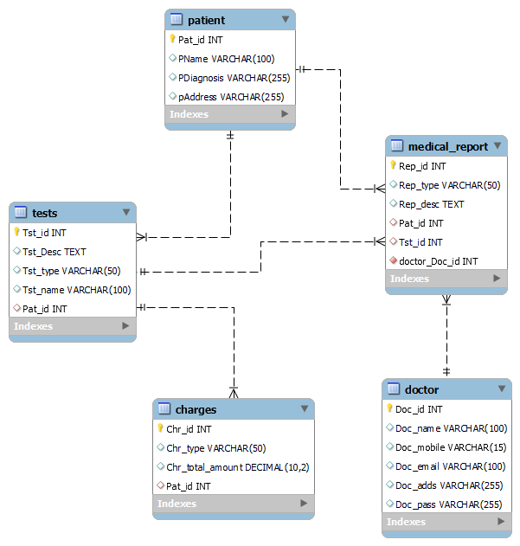

**CONCLUSION:**

In conclusion, Medical Diagnostic system project is implemented in java platform. Main aim of this project is to develop a software application for doctors and patients for immediately diagnose disease using tools which was usually done through manual process.